Given the root of a binary tree, the value of a target node target, and an integer k, return *an array of the values of all nodes that have a distance* k *from the target node.*

You can return the answer in **any order**.

**Example 1:**

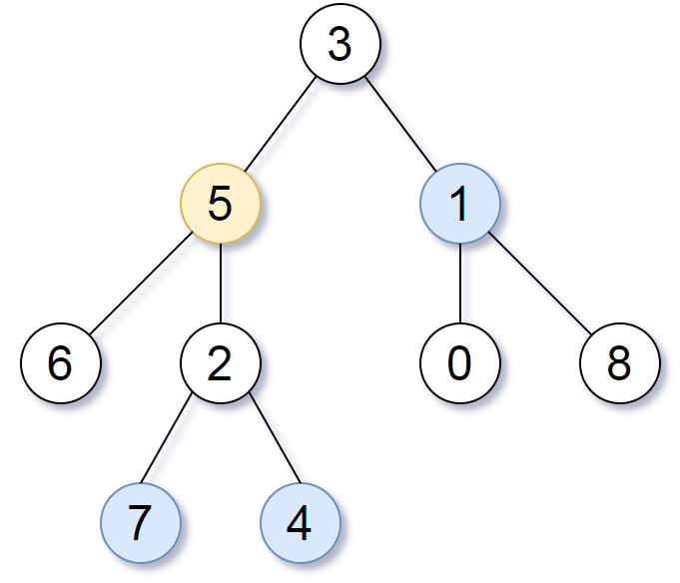

Input: root = [3,5,1,6,2,0,8,null,null,7,4], target = 5, k = 2  
Output: [7,4,1]  
Explanation: The nodes that are a distance 2 from the target node (with value 5) have values 7, 4, and 1.

**Example 2:**

Input: root = [1], target = 1, k = 3  
Output: []

**Constraints:**

* The number of nodes in the tree is in the range [1, 500].
* 0 <= Node.val <= 500
* All the values Node.val are **unique**.
* target is the value of one of the nodes in the tree.
* 0 <= k <= 1000